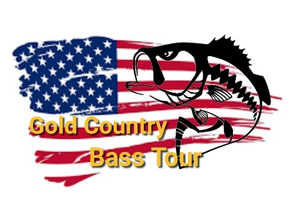
Meeting Schedule
Participants must attend any 5 meetings to qualify for TOC tournament
In Person Meetings worth 25 pts
October 3, 2020- Bob’s Marine Modesto at 4pm
January 9, 2021 – Location TBA at 4pm
April 3, 2021 – Bob’s Marine Modesto at 4pm
July 10, 2021 – Location TBA at 4pm

Online Meetings on Facebook Live worth 0 pts
November 10, 2020 – 6pm
February 2, 2021 – 6pm
March 2, 2021 – 6pm
May 4, 2021 – 6pm
June 1, 2021 – 6pm
August 3, 2021 – 6pm

