  - 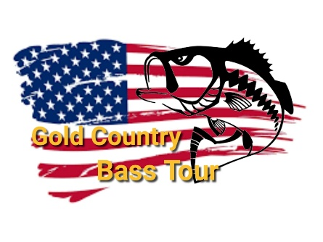
2020/2021 Season Point System
- Tournament points 1st place will receive 100 points and it will drop 2 points for every position after. There will be 1 tournament throw out.
Example:
1st place 100 points
2nd place 98 points
3rd place 96 points
And so, on
- Outreaches will be worth 10 points. There will be 1 outreach throw out.
- There will be 4 in-person meetings this season. They will be worth 25 points each. There will NOT be a throw out for meetings (October, January, April, July)
- There will be 7 Facebook Live meetings that will not be worth any point but will count for your 5 required meetings to qualify for TOC
- Big fish from each tournament will receive 3 bonus points
- Remember you need to participate in 5 Tournaments, 5 Outreaches and 5 Meetings to qualify for the TOC tournament in September 2021.
- The Top 35% of participants that have completed their 5/5/5 requirements will be eligible to Fish the Gold Country Bass Tour TOC Tournament
- Example:
20 participants this season will equal top 7 in points will qualify for TOC
40 participants this season will equal top 14 in points will qualify for TOC
60 participants this season will equal top 21 in points will qualify for TOC
And so, on
- By signing the bottom, you agree that you have read, and you understand the Gold Country Bass Tour Point System.
Participant Name Printed ________________________________
Participant Signature ____________________________________ Date___________
Parent Name Printed ____________________________________
Parent/Gradian Signature ________________________________ Date__________

