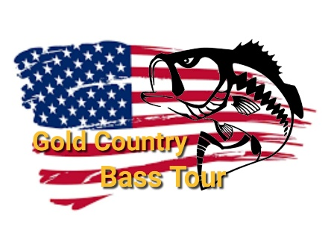
Tournament Schedule
October 18, 2020 - Don Pedro Fleming Meadows Ramp
November 14, 2020 - Lake McClure Barret Cove
January 31, 2021 - Tulloch
February 20, 2021 - Lake Camanche South Shore Ramp
February 1 -28, 2021 - Online Tournament
March 21, 2021 - Salt Springs Valley Res.
April 24 and 25, 2021 - 2 Day Tournament at New Melones Glory Hole Ramp
May 8, 2021 - New Hogan
June 13, 2021 - Pardee
June 1 – 27, 2021 - Online Tournament
July 17, 2021 - Lake McClure Barret Cove
August 8, 2021 - Amador
The end of Season Party will follow this tournament
September TOC TBA

